# <https://app.hackthebox.com/profile/1321956>

# Machine 1: Precious Type: Easy

1)ping to machine IP address

2)Conduct a Nmap scan

-Sv determine the version of the service running on port  
-V verbosity level  
-SC Scan with default NSE script

Extracted from the scan:

Redirect to another link, <http://precious.htb>

3) Modify host file.  
nano /etc/hosts



Include the Ip address and domain name and saved.

4)Copy address link to http://precious.htb/

5) Start a Http server



6) Type ifconfig on another terminal to check on the inet address.

7)Key in Http://10.10.16.17.8080

This will alert the http server and the request to retrieve the document is successful .

It will prompt user to save the PDF document .

I retrieved the directory listing of the webserver

8) I noted the application that creates the PDF and the version numbner.Use these information to find out for potential exploits.

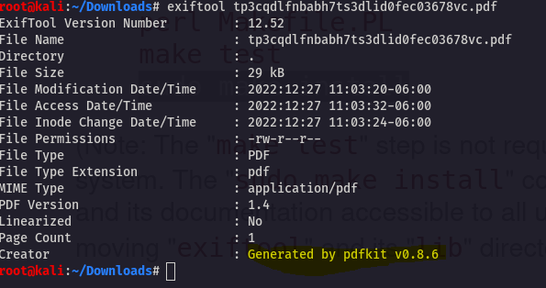

9) Search pdfkit v0.8.6 for potential exploits in a web browser. It is prone to command injection.

Research

With command below ,I will check if the webserver is prone to command injection

Using the following code ,I received a response from the Http server. I can confirm that the webserver is prone to command injection

Yes. It is prone to command injection as its was captured in the python http server.

10) Creating a reverse shell

11)Whoami>Ruby (interacting as Ruby)

There are 2 users ; Henry and Ruby

12) Elevate the privileges as Henry. I check the listings in the Ruby’s directories

Directories

13)Use find command to list every file on this directories

There is a file named config located under the bundle directory. “Cat” the content to see the information inside.

14)It displays Henry’s password. With Henry’s password I can elevate the privileges from Ruby to Henry.

15) Change privileges to Henry. Currently I’m accessing the system as Henry.

Under henry there are 2 files: dependencies.yml and user.txt

16)Read the content in the user.txt.  
e210c900a319bde77759ba8ff7a6d74f



17)Checking on Henry’s pseudo privileges. It seems that we can run a ruby script named “update_dependencies.rb”.This does not require any password.

The script uses a function called YAML.load(File.read(“dependencies.yml”)). This method is vulnerable to deserialization attack.

18)Research on YAML.load method

It provides a payload that we can use in Github.

19)Copy the codes for the payload execution.

20)Checking the read, write access for the different access groups

21)Changing the mode to ROOT.

root.txt=0d84d5b477e030dd198a0582ac575ecc

# References:

<https://book.hacktricks.xyz/pentesting-web/nosql-injection>

<https://gtfobins.github.io/gtfobins/docker/#shell>

<https://gtfobins.github.io/>

<https://www.techrepublic.com/article/how-to-quickly-give-users-sudo-privileges-in-linux/#:~:text=To%20use%20this%20tool%2C%20you,%2Fsudoers%20file%20for%20editing).&text=Save%20and%20close%20the%20file,full%20range%20of%20sudo%20privileges>.

<https://book.hacktricks.xyz/pentesting-web/nosql-injection>

<https://www.imperva.com/learn/application-security/nosql-injection/#:~:text=The%20main%20differences%20between%20NoSQL,don't%20use%20standardized%20languages>.

<https://github.com/danielmiessler/SecLists>

<https://portswigger.net/web-security/file-path-traversal>

<https://github.com/pentestmonkey/php-reverse-shell>